Annular Solar Eclipse - June 10, 2021

Early on June 10, 2021, you can witness an incredible celestial event: a solar eclipse. These events are rare, so don't miss out on this once-in-a-lifetime chance!

NEVER LOOK AT THE SUN WITH THE UNAIDED EYE, INCLUDING DURING AN ECLIPSE!
ALWAYS USE THE ECLIPSE GLASSES PROVIDED
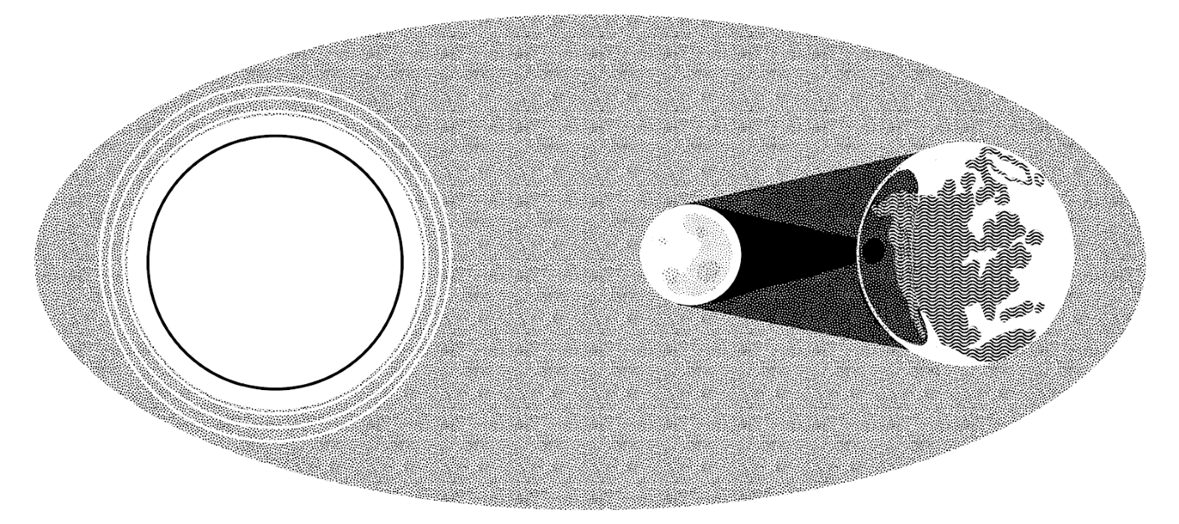
What is a solar eclipse?
A solar eclipse happens when the Moon passes between the Earth and the Sun, casting a shadow on the Earth. From our perspective, this will look like the Moon is blocking out the Sun. This particular eclipse is an annular eclipse, which means that at its maximum, you will see a ring, or annulus, of the Sun around the Moon.

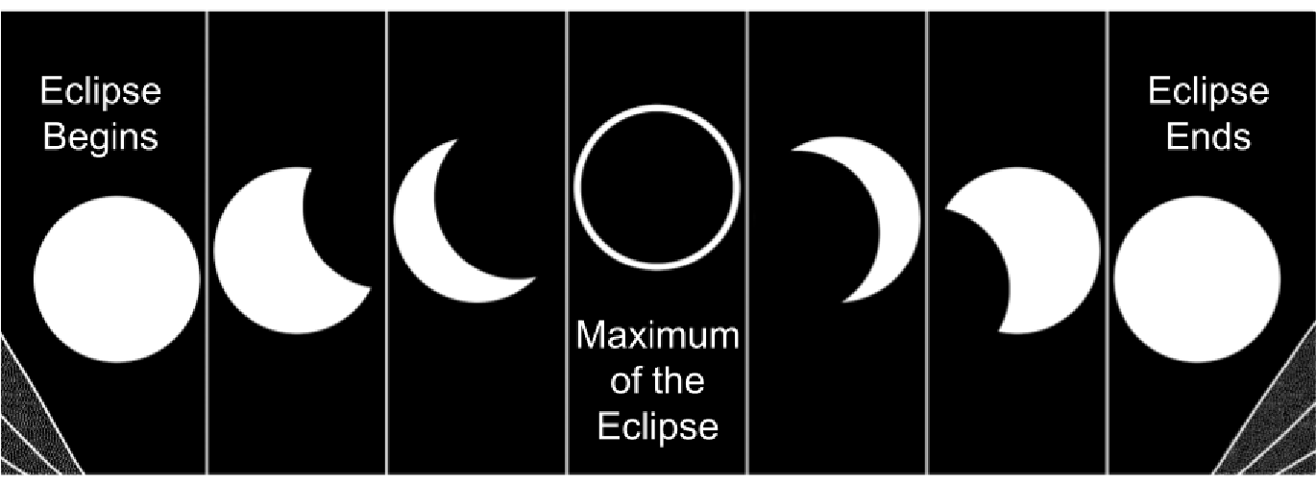
What will happen on June 10, 2021? From beginning to end, the eclipse will be visible for about 2 hours. You can watch the whole thing, but the maximum of the eclipse is the best part and will only last a few minutes. USE THE ECLIPSE GLASSES to look at the Sun a few times during the 2-hour period to see the eclipse evolve and be sure not to miss the maximum!
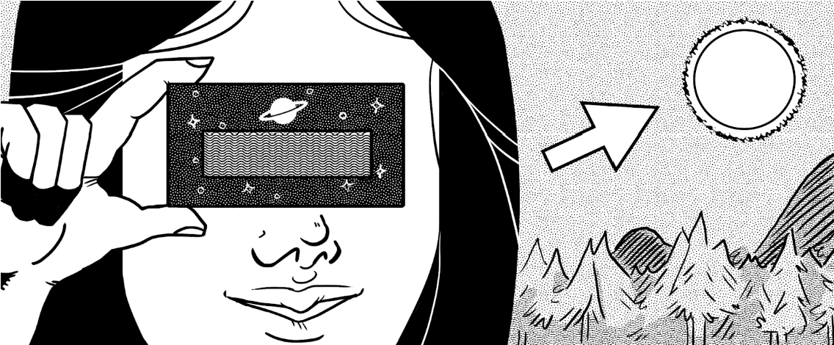
Safety precautions
It is completely safe to observe the eclipse while wearing eclipse glasses, as they block 99.997% of the Sun's light . You can be outside with your family and take turns sharing glasses for everyone to look at the Sun.

Never look at the Sun without wearing eclipse glasses, even during an eclipse, as light from the Sun will injure your eyes and could damage your eyesight forever. Supervise children carefully and do not use your eclipse glasses if they are scratched.

The eclipse will happen at different times in different regions. Fill out the table below with help from your teacher, classmates, or family:

Where do you live? | Start time of the eclipse | Time of eclipse maximum | End time of the eclipse
North Bay, Ontario | Thurs. June 10, 2021 at 5:25 am | 5:43 am 0.889 Magnitude | Thurs., June 10, 2021 at 6:42 am

https://www.timeanddate.com/eclipse/in/canada/north-bay

For more information, hit the link above.

